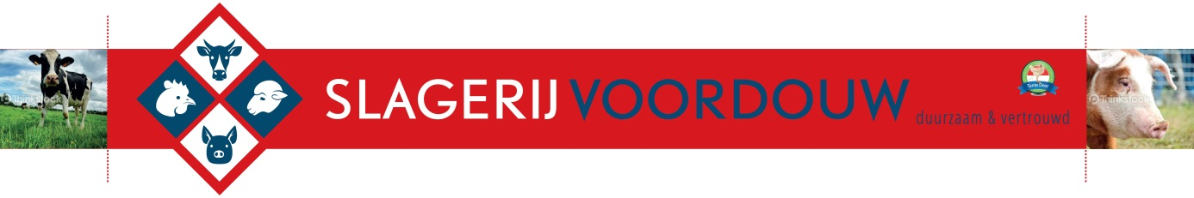

DIVERSEN BROODJES

|  |  |  |  |  |  |  |  |  |  |  |  |  |  |  |  |  |  |  |  |  |  |  |  |  |  |  |  |  |  |  |  |  |  |  |  |  |  |  |  |  |  |  |  |  |  |  |  |  |  |  |  |  |  |  |  |  |  |  |  |  |  |  |  |  |  |  |  |  |  |  |  |  |  |  |  |  |  |  |  |
| --- | --- | --- | --- | --- | --- | --- | --- | --- | --- | --- | --- | --- | --- | --- | --- | --- | --- | --- | --- | --- | --- | --- | --- | --- | --- | --- | --- | --- | --- | --- | --- | --- | --- | --- | --- | --- | --- | --- | --- | --- | --- | --- | --- | --- | --- | --- | --- | --- | --- | --- | --- | --- | --- | --- | --- | --- | --- | --- | --- | --- | --- | --- | --- | --- | --- | --- | --- | --- | --- | --- | --- | --- | --- | --- | --- | --- | --- | --- | --- |
| |  |  |  |  |  | | --- | --- | --- | --- | --- | | Rosbief | |  |  | € 2,75 | | Boerenham | | |  | € 2,75 | | Grillworst | |  |  | € 2.25 | | Kaas |  |  |  | € 2,25 | | Carpacchio | | |  | € 4,00 | | Half om | |  |  | € 2,75 | | Bal |  |  |  | € 2,75 | | Eiersalade | |  |  | € 2,00 | | Garnalensalade | | |  | € 3,50 | | Krabsalade | | |  | € 3,50 | | Paté |  |  |  | € 2,50 | | Salami | |  |  | € 2,50 | | Cervelaat | |  |  | € 2,25 | | Filet |  |  |  | € 2,75 | | Div. Salade | | |  | € 2,50 | | |  |  |  |
|  | | |  |  |
|  | |  |  |  |
|  |  |  |  |  |
|  | | |  |  |
|  | |  |  |  |
|  |  |  |  |  |
|  | |  |  |  |
|  | | |  |  |
|  | | |  |  |
|  |  |  |  |  |
|  | |  |  |  |
|  | |  |  |  |
|  |  |  |  |  |
|  | | |  |  |