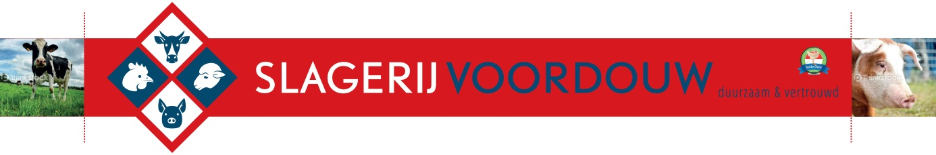

DIVERSEN BROODJES

|  |  |  |  |  |  |  |  |  |  |  |  |  |  |  |  |  |  |  |  |  |  |  |  |  |  |  |  |  |  |  |  |  |  |  |  |  |  |  |  |  |  |  |  |  |  |  |  |  |  |  |  |  |  |  |  |  |  |  |  |  |  |  |  |  |  |  |  |  |  |  |  |  |  |  |  |  |  |  |  |
| --- | --- | --- | --- | --- | --- | --- | --- | --- | --- | --- | --- | --- | --- | --- | --- | --- | --- | --- | --- | --- | --- | --- | --- | --- | --- | --- | --- | --- | --- | --- | --- | --- | --- | --- | --- | --- | --- | --- | --- | --- | --- | --- | --- | --- | --- | --- | --- | --- | --- | --- | --- | --- | --- | --- | --- | --- | --- | --- | --- | --- | --- | --- | --- | --- | --- | --- | --- | --- | --- | --- | --- | --- | --- | --- | --- | --- | --- | --- | --- |
| |  |  |  |  |  | | --- | --- | --- | --- | --- | | Rosbief | |  |  | € 3.00 | | Boerenham | | |  | € 3.00 | | Grillworst | |  |  | € 2.50 | | Kaas |  |  |  | € 2,50 | | Carpacchio | | |  | € 4,50 | | Half om | |  |  | € 3.00 | | Bal |  |  |  | € 3.00 | | Eiersalade | |  |  | € 2,50 | | Garnalensalade | | |  | € 4.00 | | Krabsalade | | |  | € 4.00 | | Paté |  |  |  | € 3.00 | | Salami | |  |  | € 2,50 | | Cervelaat | |  |  | € 2,50 | | Filet |  |  |  | € 3.00 | | Div.Salade vanaf | | |  | € 2,50 | | |  |  |  |
|  | | |  |  |
|  | |  |  |  |
|  |  |  |  |  |
|  | | |  |  |
|  | |  |  |  |
|  |  |  |  |  |
|  | |  |  |  |
|  | | |  |  |
|  | | |  |  |
|  |  |  |  |  |
|  | |  |  |  |
|  | |  |  |  |
|  |  |  |  |  |
|  | | |  |  |